6.3 Engage with colleagues and improve practice

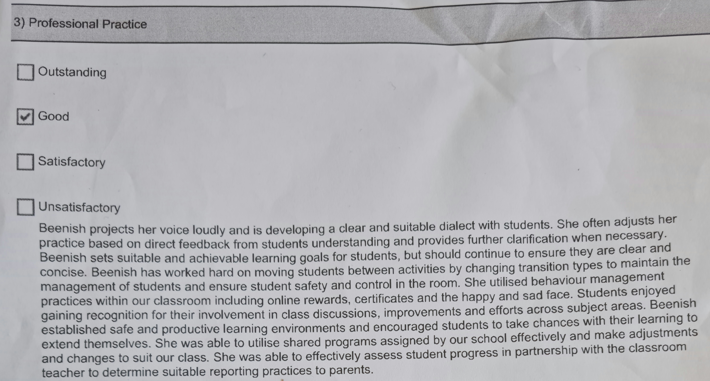

Seek and apply constructive feedback from supervising teacher to improve class room management and reporting practices to parents.

