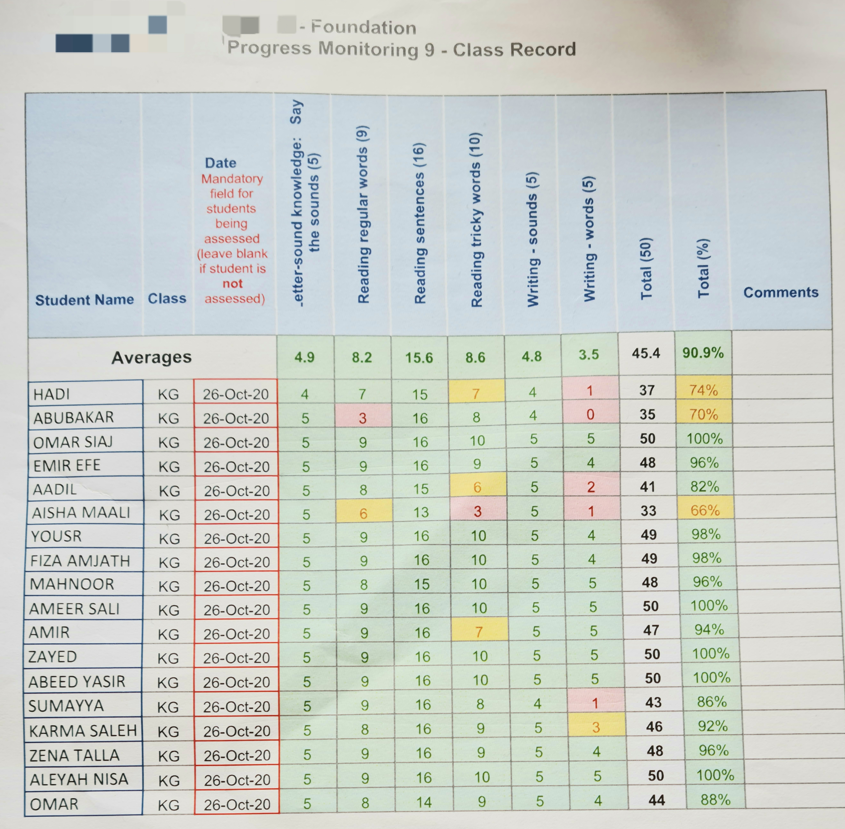

Students requiring extension

**Modification in teaching practice included:**

* Encouraging students to use tricky ‘word tree’ for writing activities.
* Practice reading decodable readers suitable to the level with special attention to tricky words.
* Playdough tricky word formation activity.
* Provide tricky words for practice at home.

**5.4 Interpret Student data**

**Context: Progress Monitoring Report used within IntiaLit Foundation Program, as an explicit phonics instruction, adopted for teaching fundamentals of literacy recommended by (Good to Great Schools Australia 2013 P.6).**

**Interpretation**

‘Writing words’ and ‘reading tricky words’ are two components that require additional practice evident through individual students’ performance. It is further confirmed by the average of the whole class in each of these components.

Students who require additional support, and are below 75%