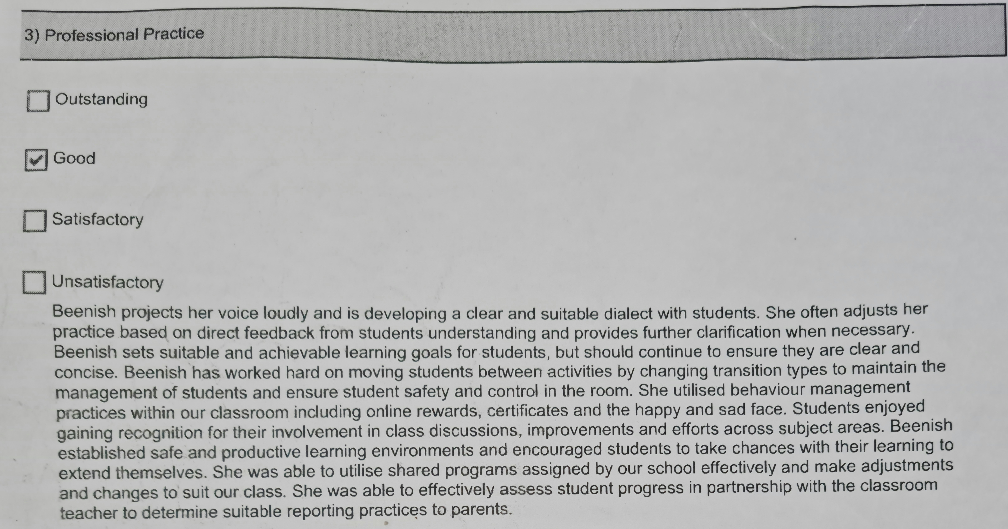
Goal: Refine verbal classroom communication. (AITSL 3.5)
Concise instructions and rechecking, if the message is understood, especially in Junior primary classrooms by asking them to repeat the instructions to ensure clarity.
6.1 Identify and plan for professional learning needs

