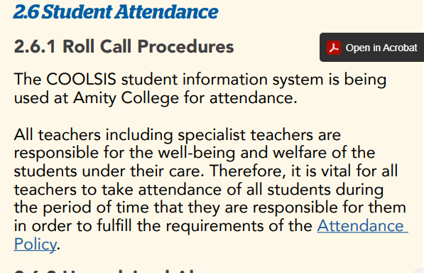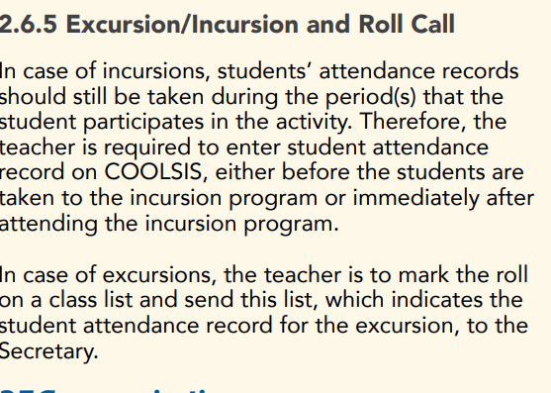
7.2 Comply with legislative, administrative and organisational requirements
Excerpts from school’s staff handbook, informing teachers about legislative administrative and organisational policies to be observed by teachers
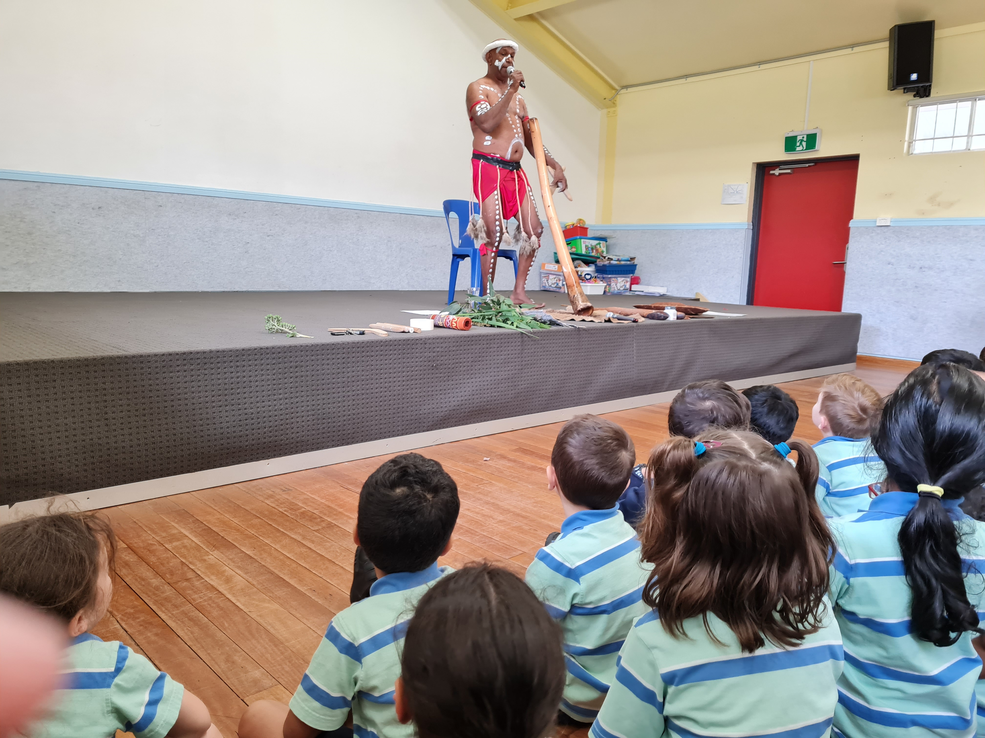
Attendance taken after Incursion by Diramu Aboriginal Dance and Didgeridoo
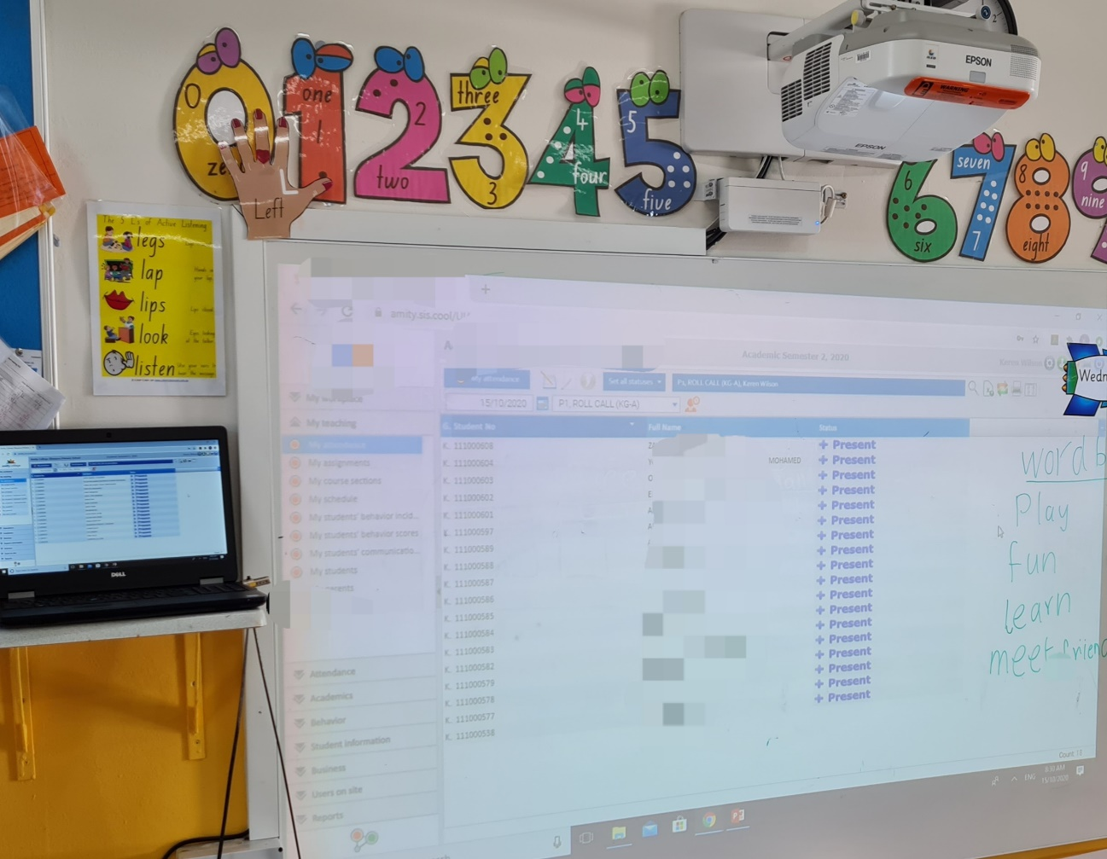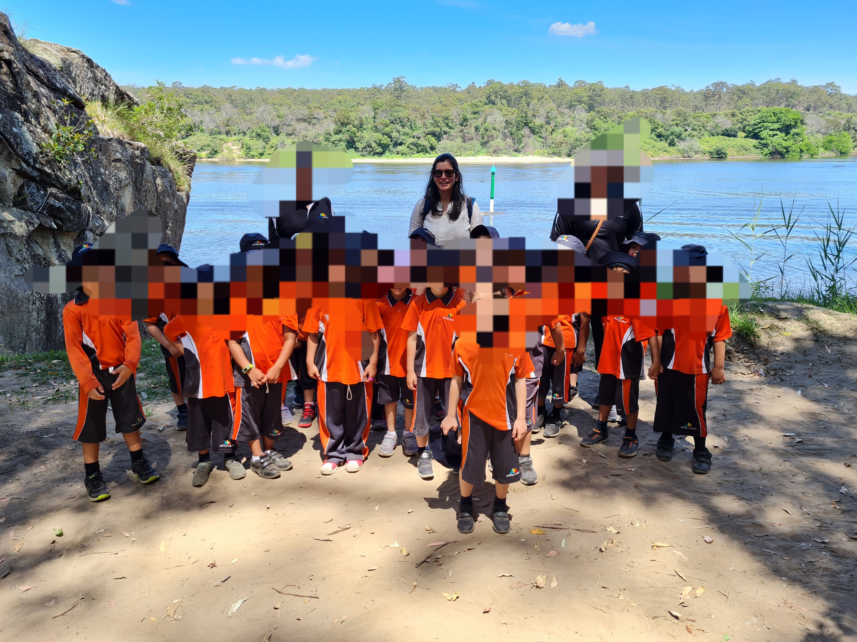
End of Term, Zoo Excursion tied to Geography’s topic of ‘Special Places’ with kindergarten students, I ensured to take roll call on a class list sent to office prior departure and regular checking of the total number during excursion.
Regular attendance taken in compliance of school’s policy to ensure wellbeing and welfare of students

