3.4 Select and Use Resources

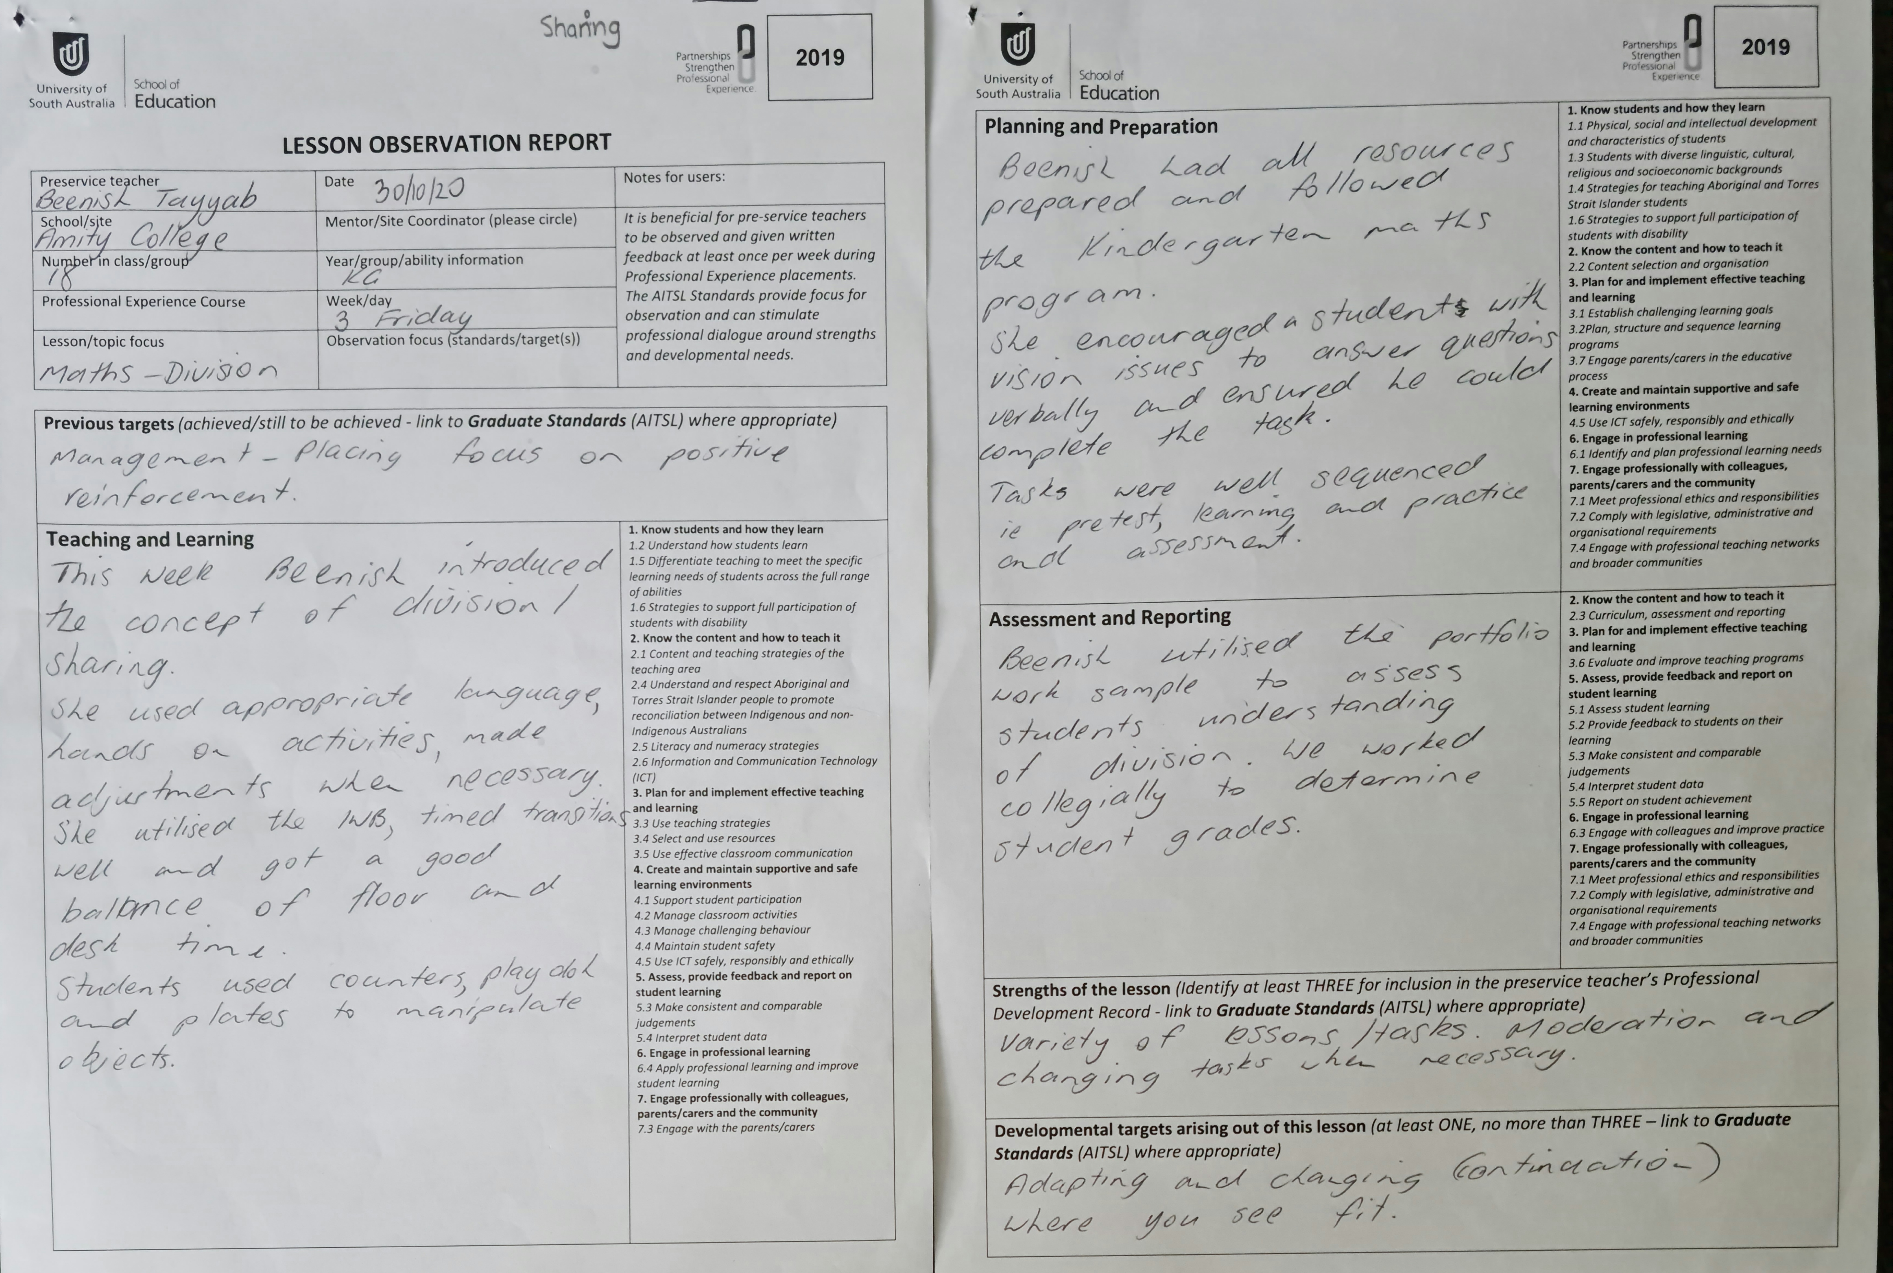
Selection of wide range resources including ICT
Effective use of resources, aligned to objectives

