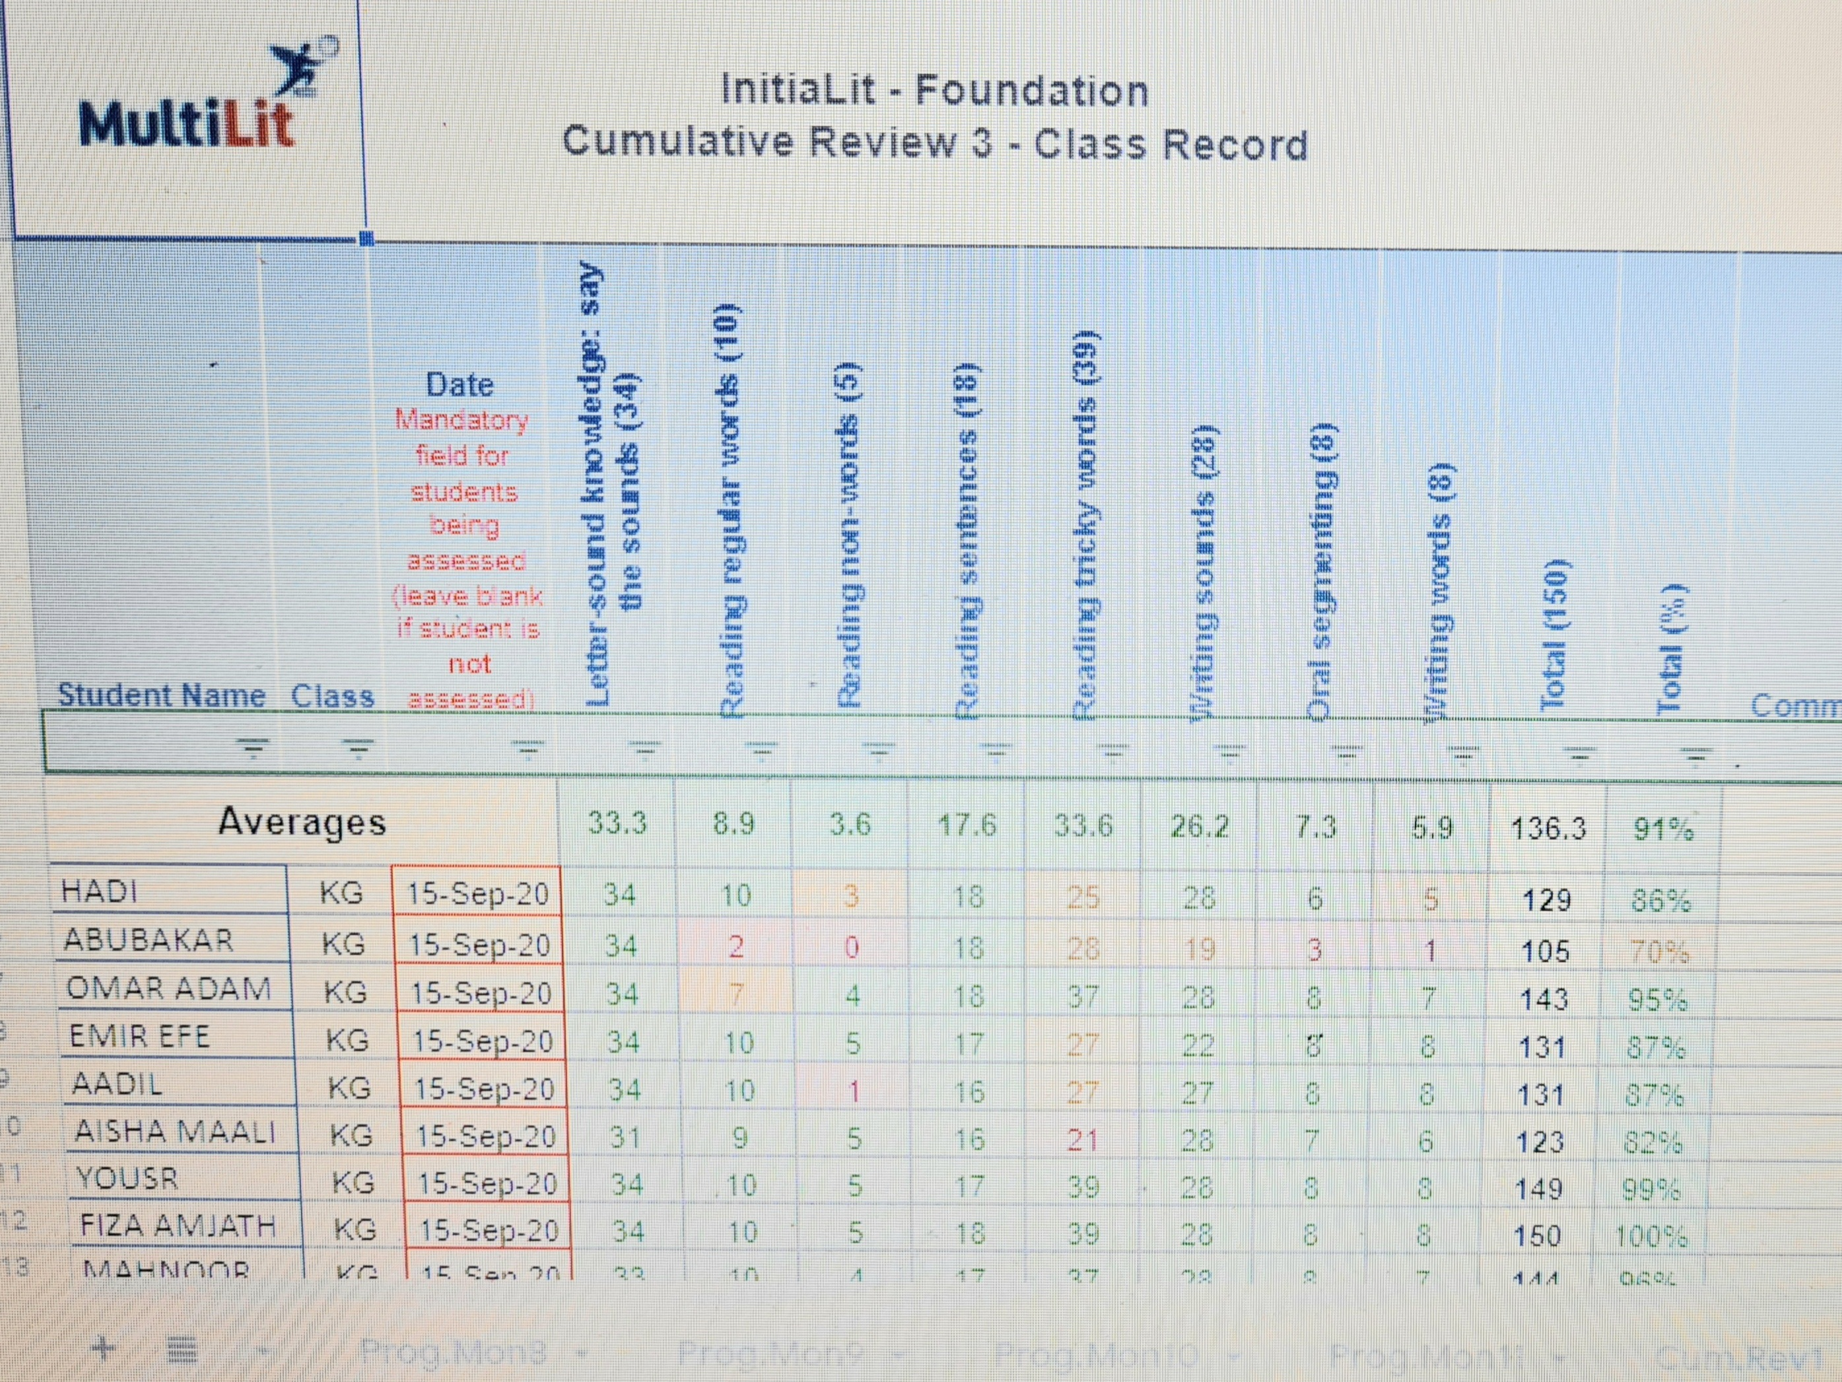
5.5 Report on Student achievement
Context: A summative assessment of an explicit instruction literacy program (Intialit Foundation) that is administered at the end of the term to assess the overall achievement of each student in each component of literacy and as an analysis of comprehensive achievement in all components. This report is used for reporting to the parents and students about their overall progress and is part of the portfolio assessment with work samples. This assessment is also used to evaluate teacher’s performance and areas of future development.

