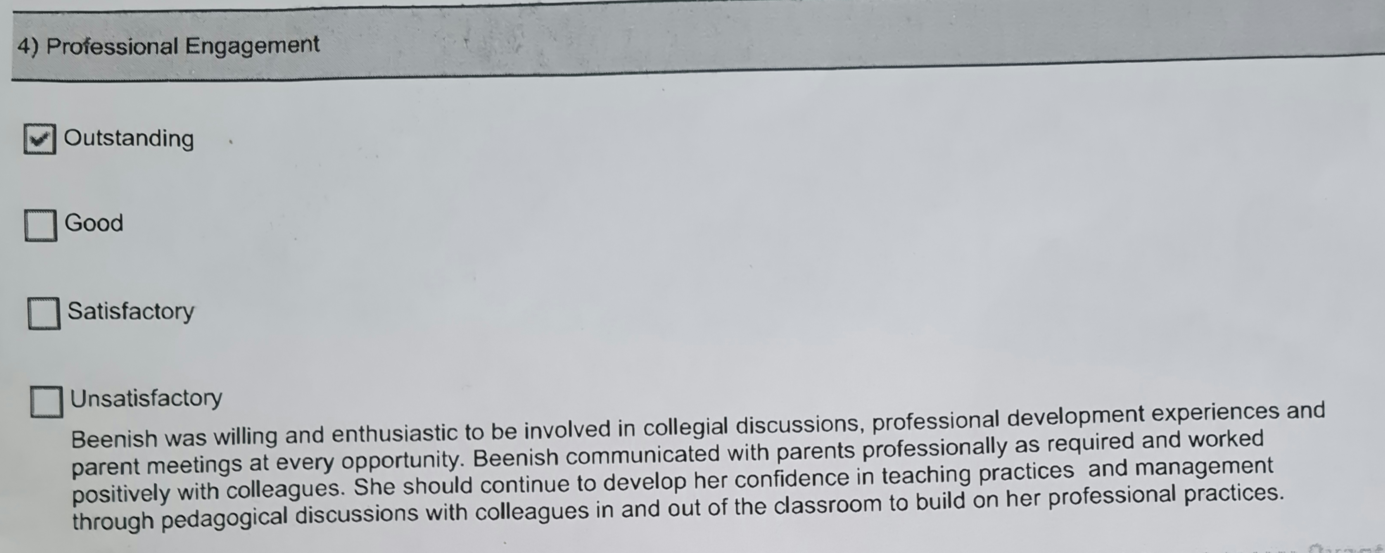
Demonstration of Ethics and responsibilities by engaging professionally with my colleagues, Mentor teacher and parents

