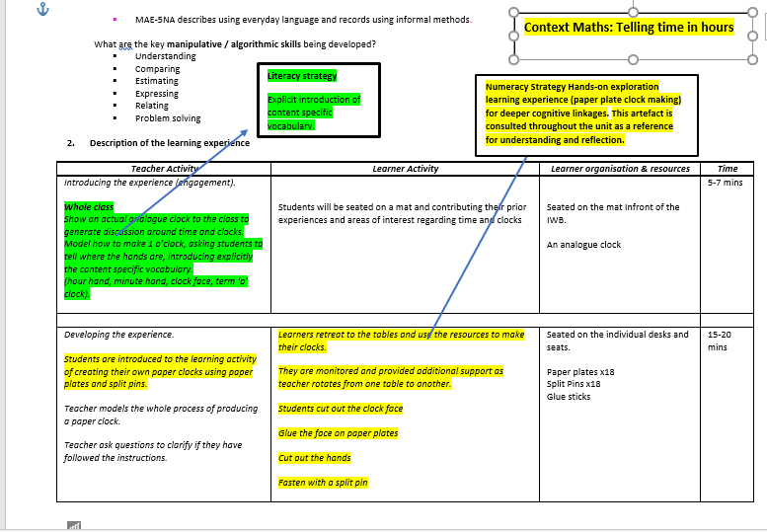
Section of a Maths lesson plan where students make paper-plate clocks
2.5 Literacy and numeracy strategies

