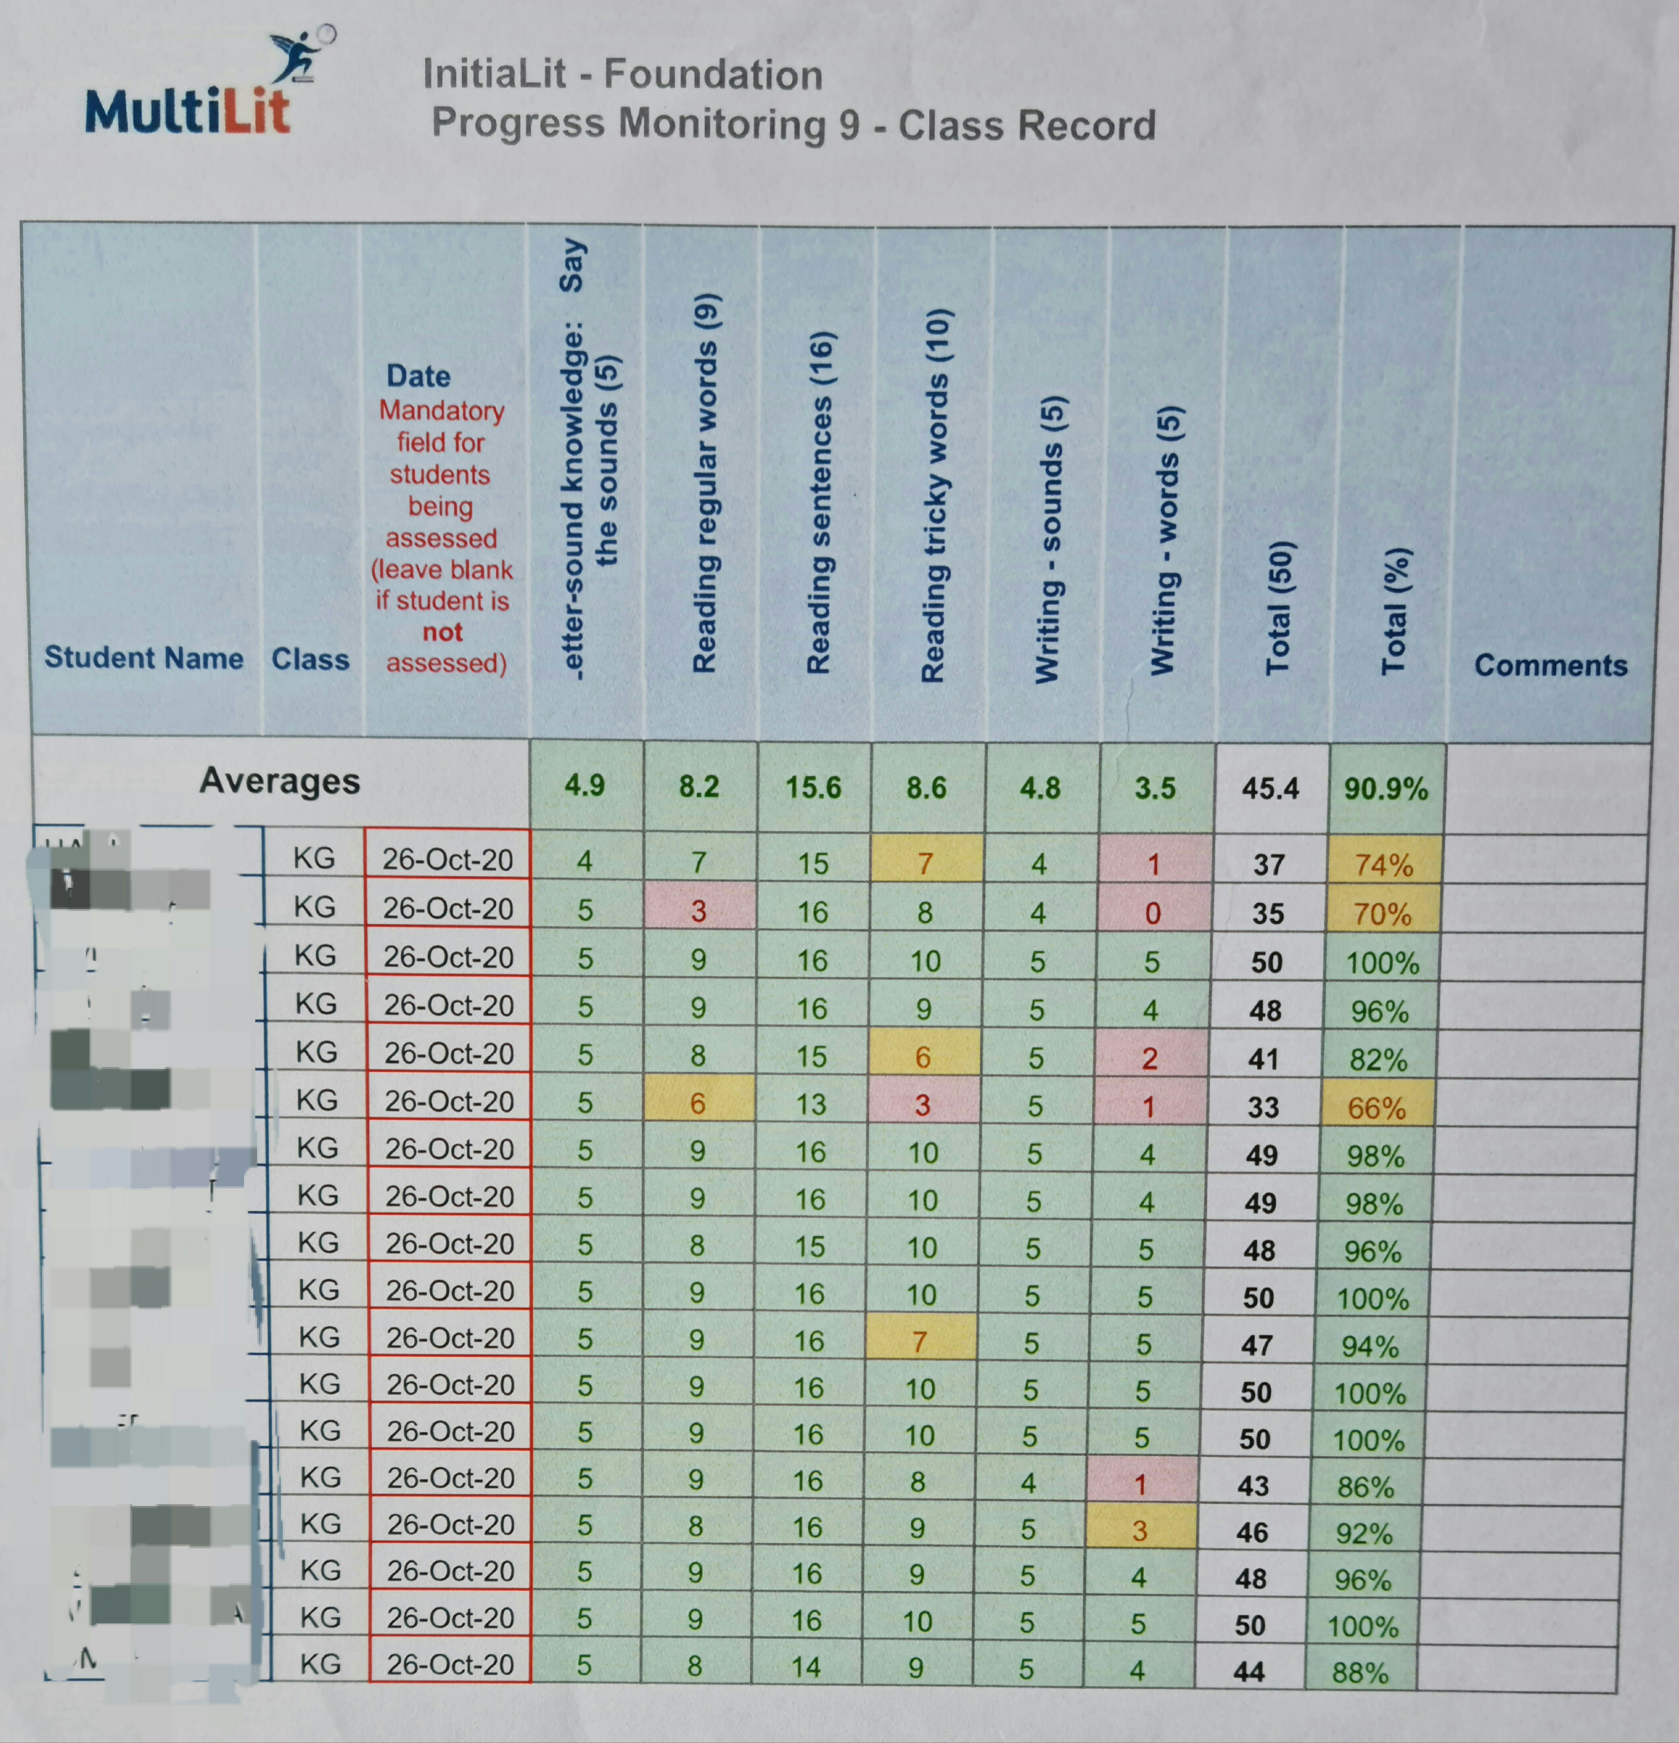
A progress monitoring program to assess student’s overall performance and specific areas to inform next round of pedagogical decisions. This data is used to shed light on teacher’s practice, pace and delivery.
Green: represent Working at
Yellow: Working at
Red: working below
Conducted after around 10 lessons.

2.6 Information and communication Technology to expand curriculum learning opportunities
Effectiveness of overall round of lessons
Average for the class to compare performance

