4. 3Manage Challenging Behaviour

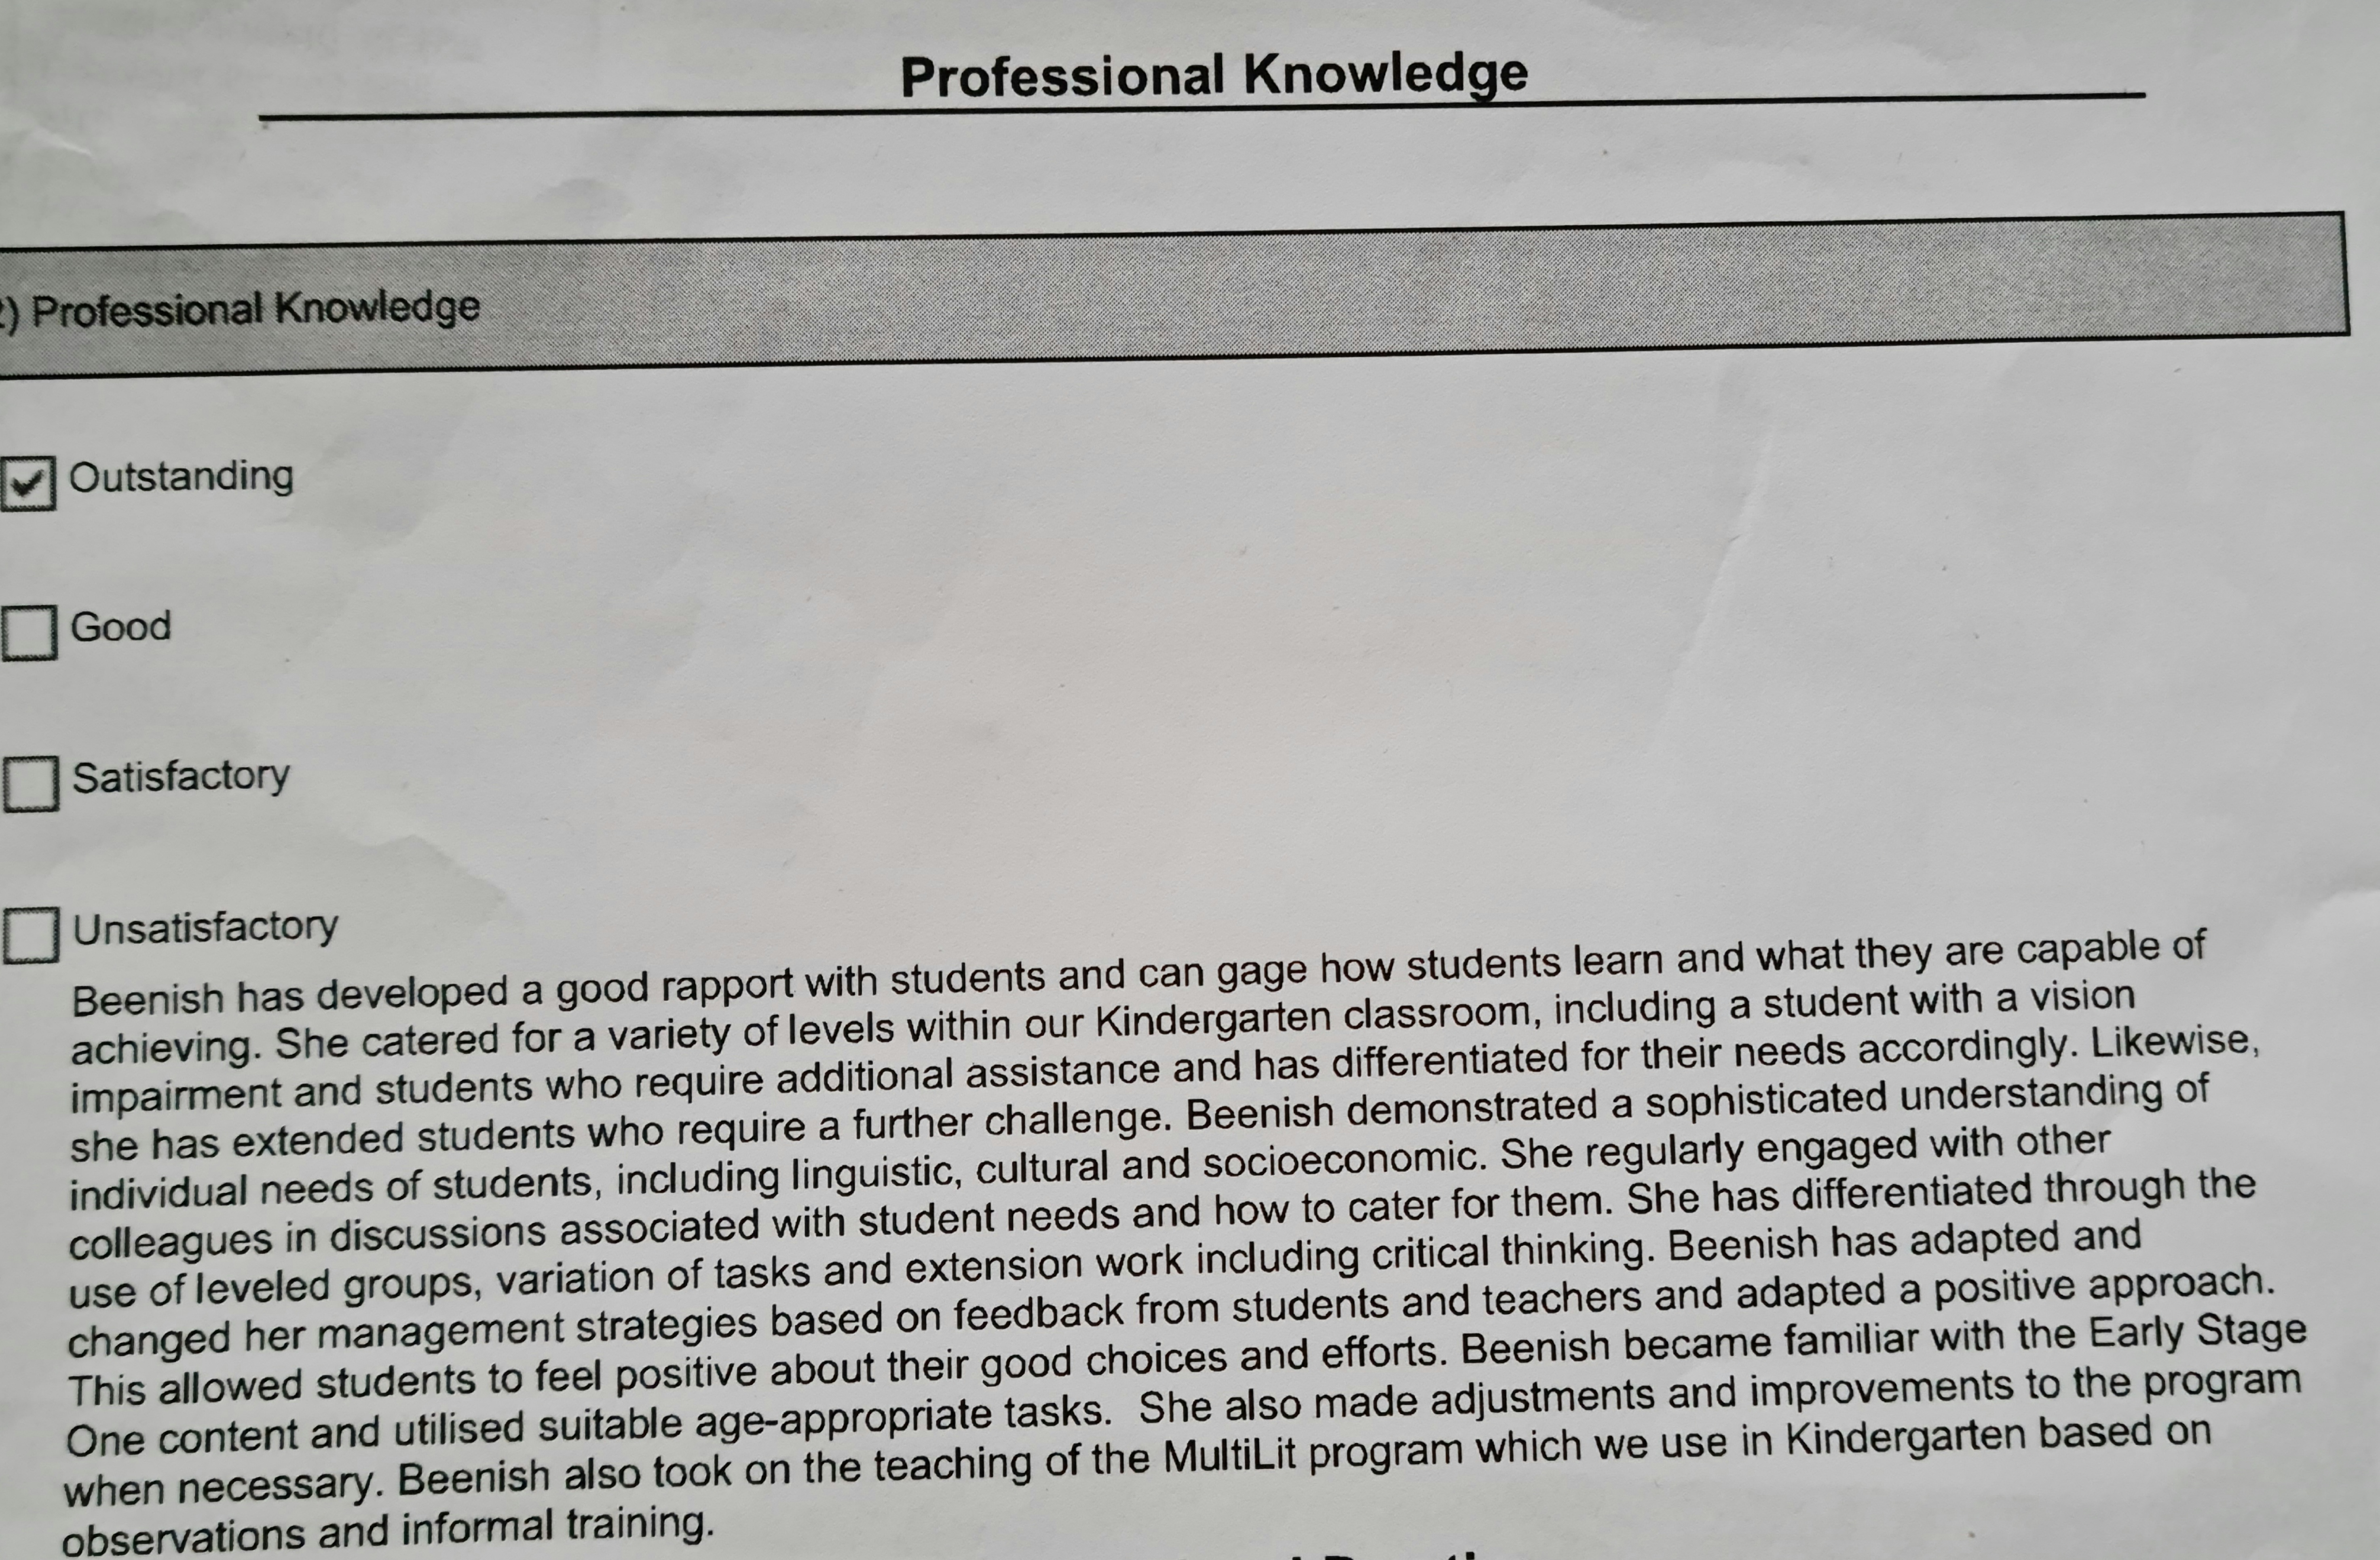
Acknowledging positive behaviour
Relationships and Background knowledge
Collaboration with teachers and students
Age- appropriate engaging tasks
Differentiation

