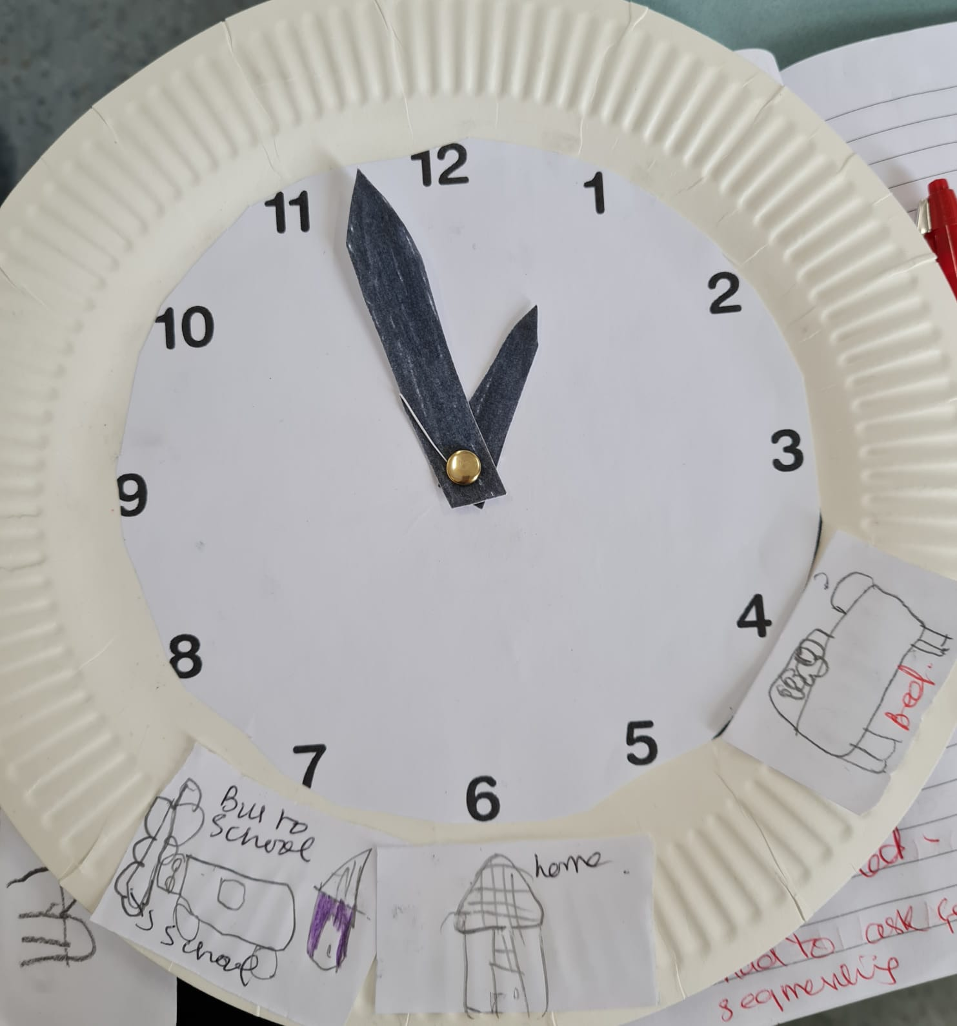
Differentiation in expression of thinking through drawing or writing as students are still learning to write.
At 4 ‘o’clock in morning, sleeping
Concept of a.m. not introduced as yet
Comment: The student was competent in procedural knowledge of reading clocks and telling accurate time in hours hence she was extended to connect her procedural knowledge to real life situations. This extension activity was within her zone of proximal development and developed higher order thinking by applying learnt skills to authentic real situations.
Evidence A: Work sample (Extension)
Differentiation Focus (Content): Relating time to the hour to activities of the day and transferring skills to real world experiences.
1.5 Differentiate teaching to meet the specific learning needs of students across full range of abilities

At home, 6 ‘o’clock
In the morning, still at home.
At 7 ‘o’ clock, bus leaves for school.

