Applying the takeaway point from staff development day on teaching students to ‘write’ effectively.

Focus: Integrating VCOP (Vocabulary, connectives, openers and punctuation) into Classroom Practice and Planning

It uses **4T model.**

* Target
* Teach
* Talk (game or activity)
* Task

6.4 Apply Professional Learning and improve student Learning

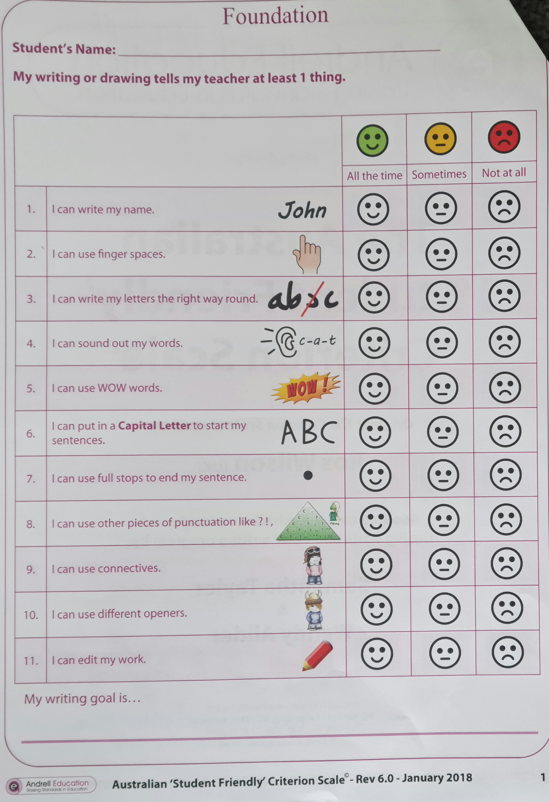

Student Friendly Criterion scale incorporated for student’s self-reflection

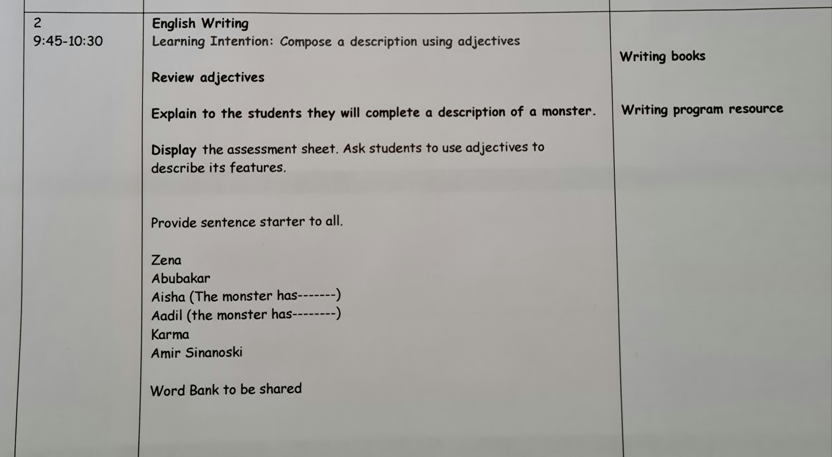

Target

Task independently

Talk: The whole program is underpinned by talk. If they can’t say it, they can’t write it. Students need to verbalise before they are expected to write.

**Game:** Flashcard game: Choose three cards from noun, verb and adjectives and make a sentence with those words about the monster displayed on the IWB

Teach