3.1 Establish Challenging Learning Goals goals

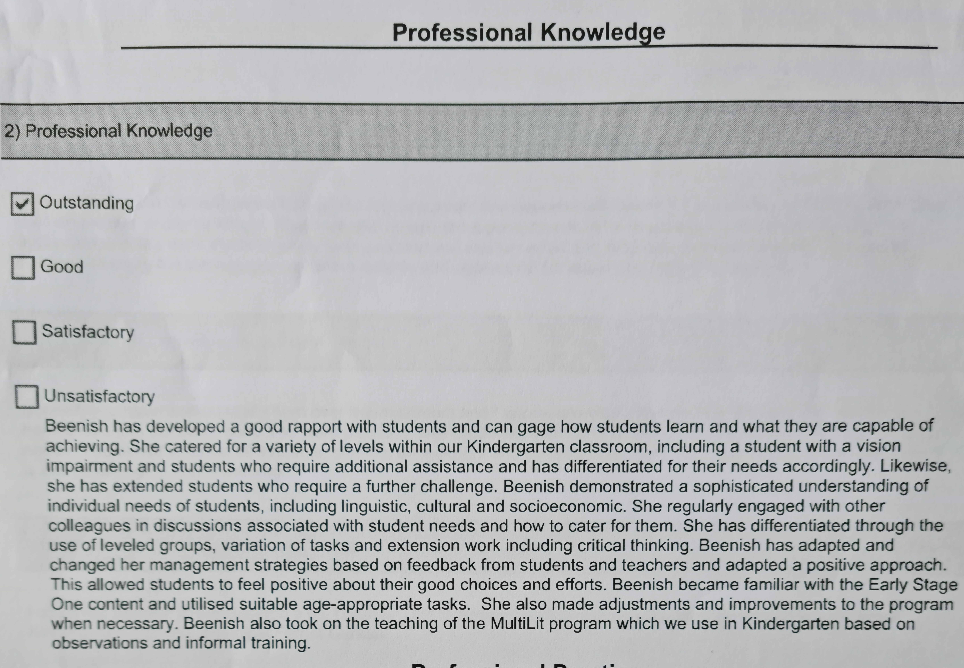
Engagement with students and colleagues to inform decisions about planning and implementation including selection of learning goals
Selection of learning goals aligned to student’s varying abilities and characteristic

