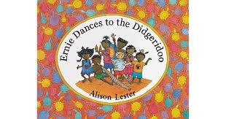
Analysis
Technology oriented fun
Discipline specific approach – English lesson and Aboriginal perspective
Nuanced approach --- Text selection and pedagogy subtly talk about the differences in culture without highlighting ‘culturally different subject’.

Strategies to teach Aboriginal and Torres Strait Islander students
Where student resides
Arnhem land (Ernie lived)
Analysis
Active style of fun
Flying kite
Dress up as mentioned in the book
play computer
Watch Tv and play X-box

