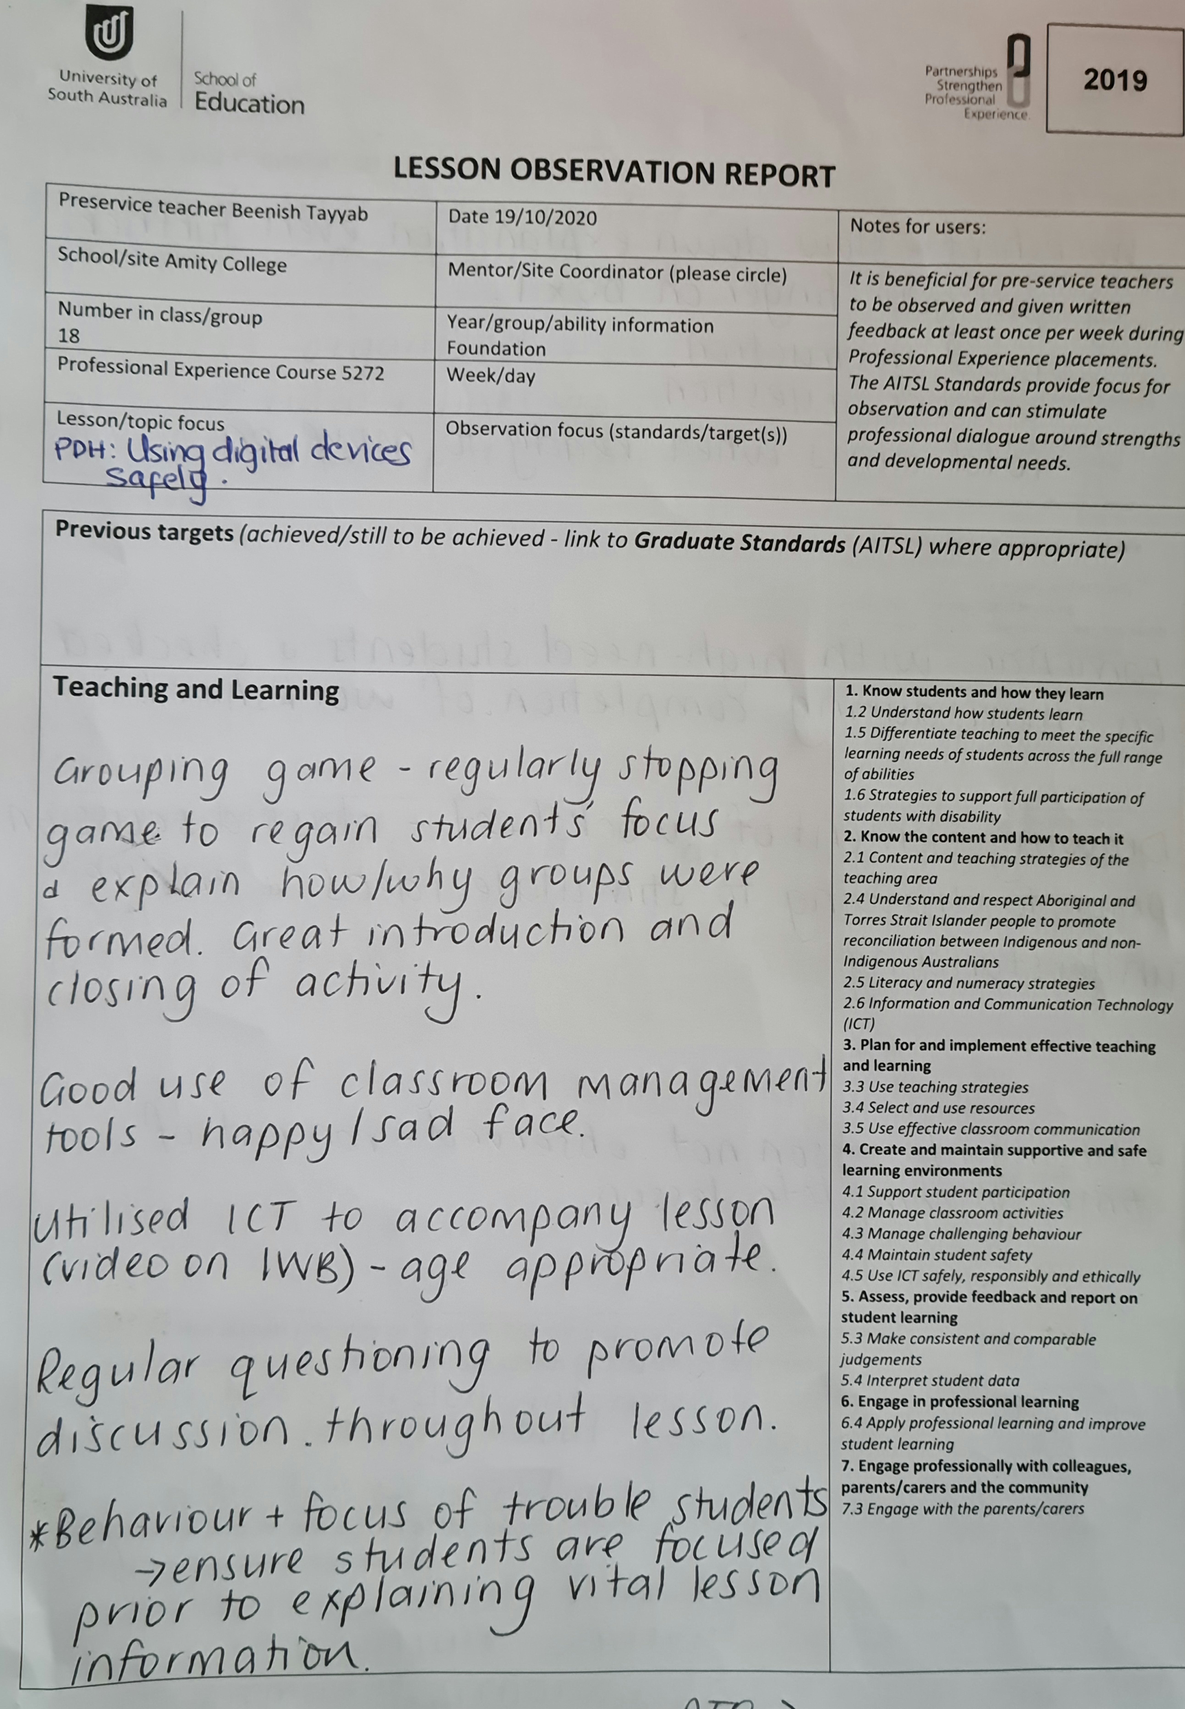
3.5 Use effective classroom Communication

