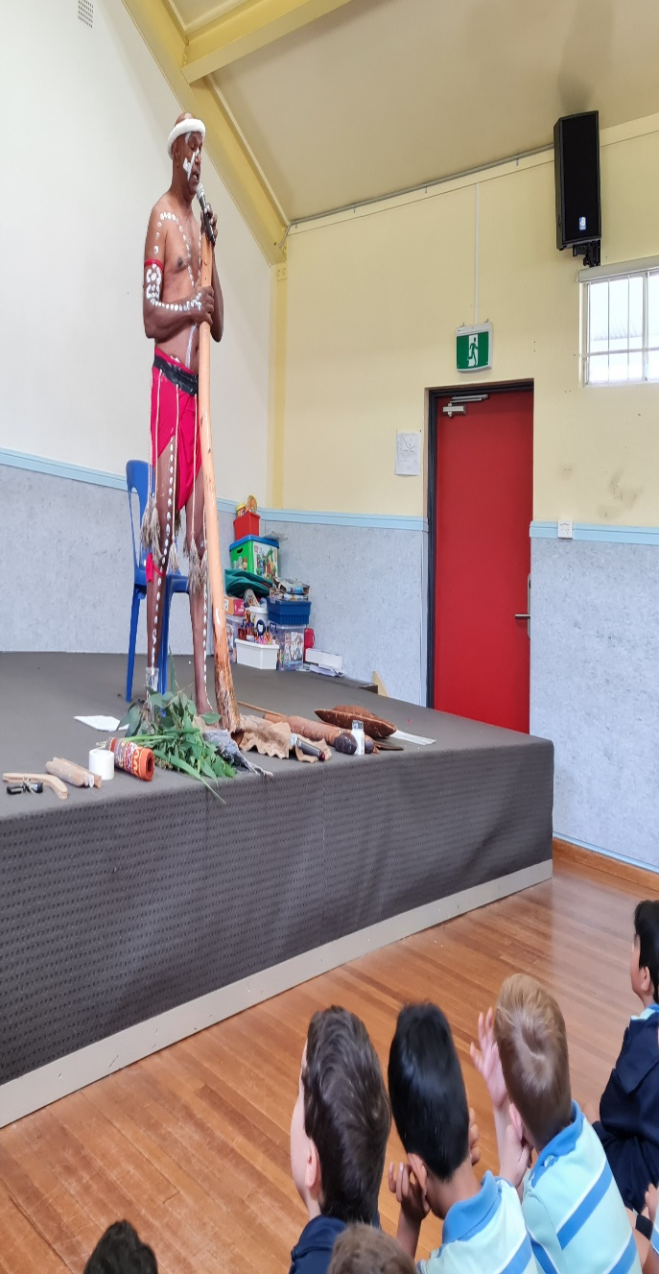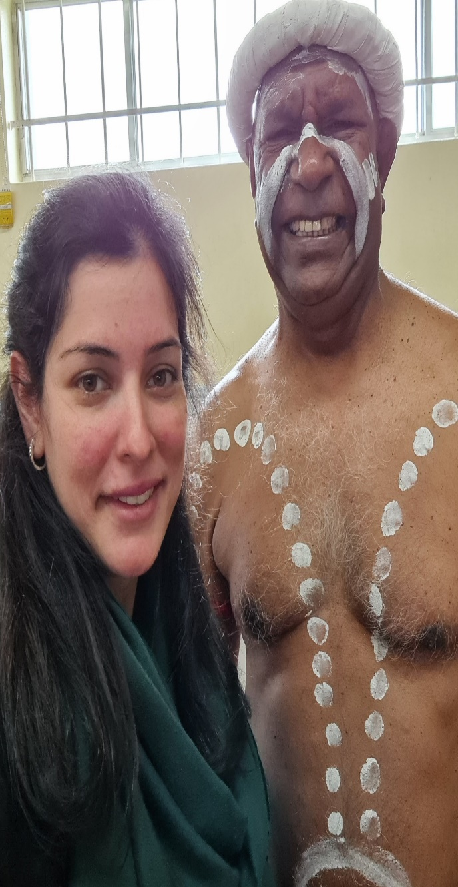
Attendance to Diramu aboriginal interactive dance and digeridoo incursion for cross cultural understanding
Direct information by aboriginal elders for local perspective and authenticity to inform culturally responsive pedagogy (Foley 2007; Moodie &Nikki 2017; Osborne 2017)
2.4 Understand and Respect Aboriginal and Torres strait Islander people histories, culture and language

