4.2 Manage Classroom Activities

Organisation of classroom activities
4.2 Manage Classroom Activities

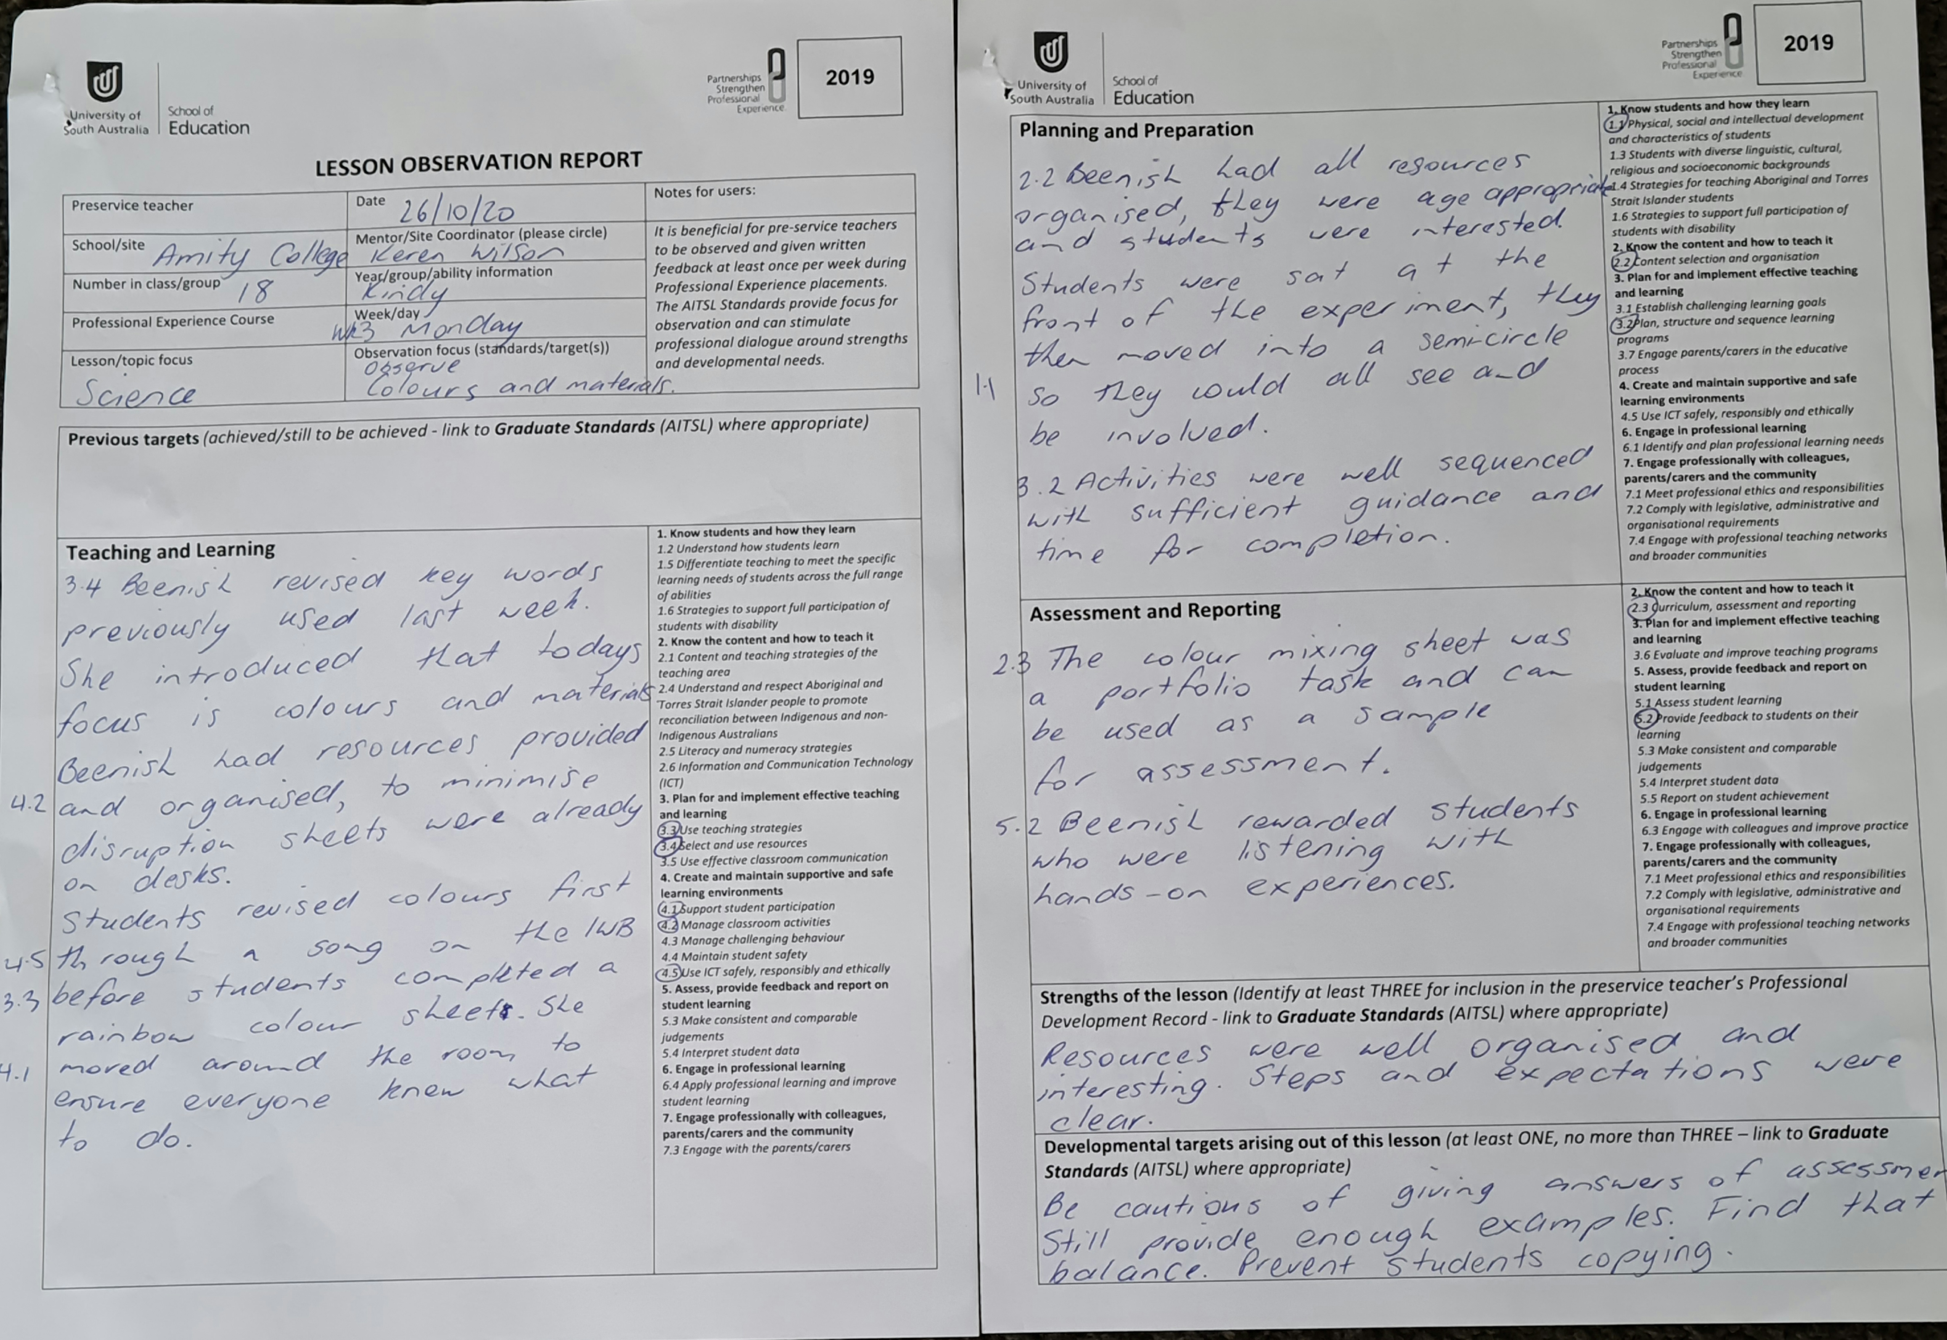
Clear Directions
Organisation of classroom activities

