Context: Kindergarten students learning to read and write using phonics incorporating blending and segmenting techniques.
In this particular activity, diagraph ‘ay’ was being practiced, to spell and write words accurately, using sound boxes to emphasise each sound in a word.
Instant feedback was provided as the activity allowed on spot assessment and timely feedback to support student’s learning.
5.2 Provide feedback to students on their learning

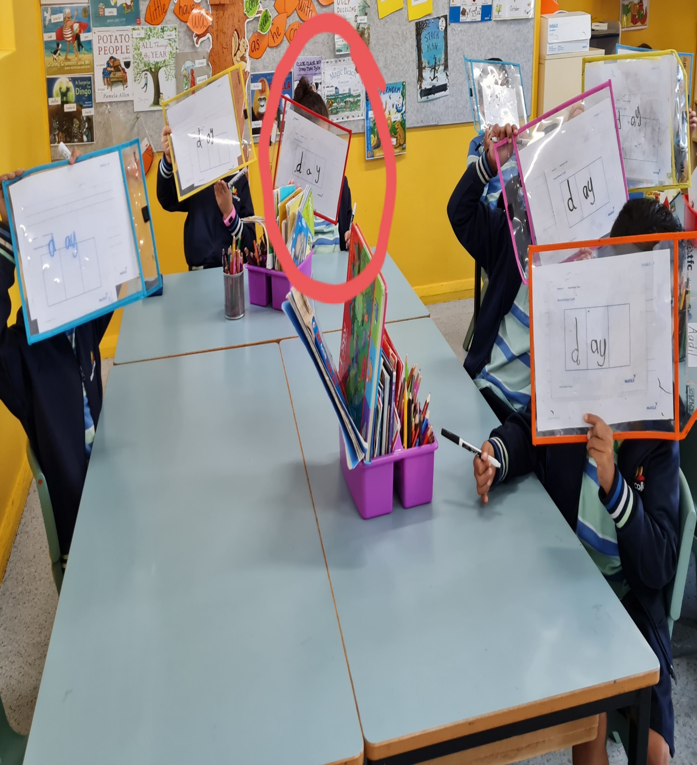
Ways of constructive feedback provided
- Started with appreciation for correct letter- sound correspondence.
- Used prompting questions effectively to navigate student to think about diagraphs being two letters one sound, hence there would be only two sounds in the word ‘day’, written as two letters in one box.
- Suggested other words ending with the diagraph ‘ay’ like ‘Hay’ or ‘May’ and revised the concept again.

Instant recognition of student needing further guidance with understanding of diagraphs ‘to spell words
The letter ‘a’ and ‘y’ are written in separate boxes representing two sounds with two letters unlike for diagraphs.

